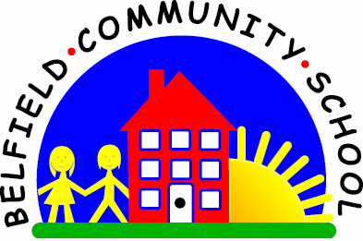
Metropolitan Borough of Rochdale
Education Committee

5.1 Understanding ‘in’, ‘on’ and ‘under’ at the simplest level
Why is this important?
Prepositions are words that describe the placement of objects. They are
important in the development of relational concepts (i.e. describing where
things are compared to others). Children need to understand prepositions
as words on their own before they can be understood in sentences
incorporating more information-carrying words.
------------------------------------------------------------------------------------------------------------------------------------------------------
What to do
• Put out a box or jar (something with a lid).
• Give the child an object (e.g. brick) and ask the child to
‘Put the brick ‘in’/‘on’/‘under’ the box’.
• Give the child another item and repeat the game.
• The child only has to understand the preposition in this task as you have given no choice of object (brick) or place (box).

