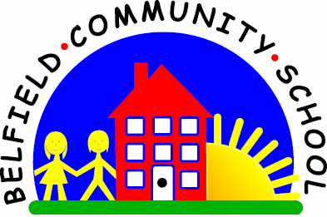
Metropolitan Borough of Rochdale
Education Committee

5.4 Learning the names of colours

Why is this important?
Colour names are adjectives often used to describe things. Children need to
understand that colours are not inextricably linked to objects (e.g. trousers
are not always blue). When children are able to match and sort objects
according to colour, then they are ready to learn the colour names.
-----------------------------------------------------------------------------------------------------------
What to do
• Gather together some bricks or Lego blocks of four different colours
(red, yellow, green and blue are ideal).
• Put out the bricks – one of each colour.
• Explain that you are going to build a tower together.
• Ask the child for a brick by colour:
★ ‘Find the red brick.’
★ ‘Put the blue brick on.’ etc.
• Always make sure there’s a choice of four colours and ask for the bricks in a random order.

