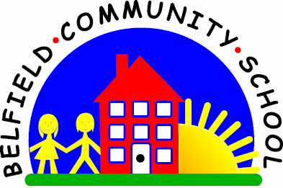
Metropolitan Borough of Rochdale
Education Committee

5.8 Beginning to use ‘what’ and ‘where’
Why is this important?
Children need to ask questions to become active learners (i.e. to take part in
their own learning). It is a critical tool in facilitating problem-solving too.
-----------------------------------------------------------------------------------------------------------
What to do
• What?
★ Share a book and take it in turns to point to something and ask ‘What is it?’
★ At snack-time (either with other children or pretend with toys) ask the child/toys
‘What shall we have to drink?’
★ Put puzzle pieces/toys/pictures into a bag.
Take it in turns to take one out and say ‘What have I got?’
• Where?
★ Again, share a book, taking it in turns to ask ‘Where’s the …?’
and then find it on the page.
★ Sort the clean washing together: put it into piles of socks, pants, trousers, etc.
or Mummy’s, Daddy’s, boy’s, etc. Take it in turns to choose something from the
basket and say ‘Where (do the) pants go?’
★ Use a variety of toys such as a doll’s house and furniture,farmyard and animals,
playground and children, etc. Take it in turns to choose an item (e.g. bed) and
ask ‘Where (does the) bed go?’

You can use the puzzle on the following page to help with this….

