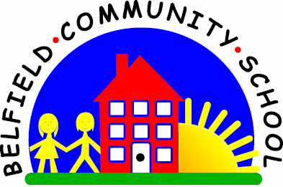
Metropolitan Borough of Rochdale
Education Committee

6.7 Understanding and using verbs in the past tense
Why is this important?
Developing the grammatical structures relating to past tense allows children
to talk about an event that has happened in the past and contrast this with
the here and now. This increases the range of language use and also allows
children to talk about things outside the here and now.
-----------------------------------------------------------------------------------------------------------
What to do
• To elicit past tense, try:
★ After playtime/lunchtime, ask the child who he/she played with and
what he/she ate, etc.
★ When playing with toys (e.g. in home corner or with the farm), ask
what food the child made for dinner or what the farmer fed the cows, etc.
★ Tell a simple story and ask the child to use the pictures to
retell the story using the past tense.
★ Play ‘Simon Says’. When the child
has performed the action, ask:
■ Adult: ‘What did you do?’
■ Child: ‘Jumped/danced/ hopped’, etc.
★ Use everyday situations to elicit past tense forms (e.g. a train goes
past, a child falls over). Ask ‘What happened?’

