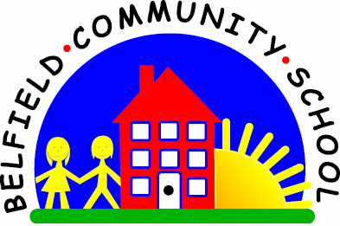
Metropolitan Borough of Rochdale
Education Committee

6.8 Generating ideas about the function of objects
(semantic links)
Why is this important?
Children need to learn that objects often have more than one function (e.g.
ball – throw it, catch it, play football) and that lots of objects perform the
same actions (e.g. what flies – butterfly, helicopter, bird, aeroplane).
-----------------------------------------------------------------------------------------------------------
What to do
• Gather together pictures of objects and put them face down on the table.
The child chooses a picture (e.g. chair):
★ Adult: ‘What do we do with a chair?’
★ Child: ‘Sit on it.’
• Give the child praise and then talk about other objects and their uses.

