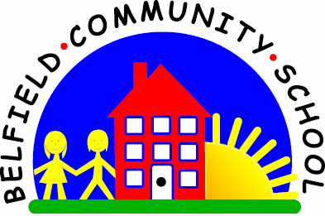
Metropolitan Borough of Rochdale
Education Committee

3.1 Learning to make sense of the world through play

Why is this important?
Pretend play helps children understand how objects are used in the real world and also leads to an awareness that toys can represent real things and people. As play skills develop, so does the knowledge of the words that represent objects as they are heard in context during play. Play is essential for children’s learning and for the development of language.
----------------------------------------------------------------------------------------------------------------------
What to do
• Get together a large doll or teddy (not miniature) and some real everyday objects
(e.g. cup, brush, flannel).
• Offer the child one of the objects (e.g. cup).
• Encourage the child to use the cup to ‘Give dolly a drink’.

