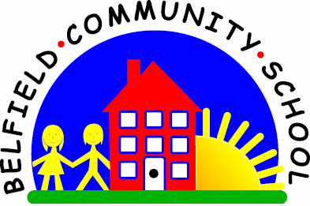
Metropolitan Borough of Rochdale
Education Committee

3.5 Understanding the words only (no cues and out of routine!)

Why is this important?
When children first begin to understand simple instructions, they use all the cues around them (e.g. routine, pointing, gestures) to work out what they need to do – the words are not necessarily the most important part! As the connection between the words and the cues is established, the meaning of the words alone begins to develop. Only when the child is able to follow instructions without the cues can we say that verbal understanding is developing.
----------------------------------------------------------------------------------------------------------------------
What to do
• It is important for the child to realise that not everything happens at the same time
every day (e.g. other children may have a swimming or music lesson one afternoon
but not every afternoon; you may have forgotten to get something from the shops
and have to go out at an unusual time). In these situations, the child can’t rely on
routine to work out what will happen.
• Try to reduce the number of additional cues (pointing, gestures) you give; so, as
an example, instead of putting your coat and shoes on first, you might say ‘Go
and get your coat’ or ‘Can you fetch Mummy’s bag?’ If the child is successful, the
words (‘coat’ or ‘bag’) alone have really been understood.

