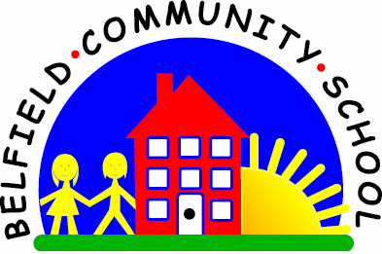
Metropolitan Borough of Rochdale
Education Committee

4.3 Understanding that ‘no’ plus an object is an early negative
Why is this important?
Children use negatives to describe the ‘absence’ or non-existence of
an object (e.g. a child finishes his/her drink and says ‘no juice’). Before
children learn to use ‘no’ in two-word phrases, they must first be able to
understand these structures and to use them appropriately.
----------------------------------------------------------------------------------------------------------
What to do
• Gather together two favourite toys (e.g. cat, puppy, doll, Spiderman).
• Use just two toys to begin with.
• From a store of everyday objects, choose a few (e.g. ball, cup, hat, socks).
• Give an object to one of the toys (e.g. put the hat on the cat’s head).
• Ask ‘Who’s got no hat on?’
• Encourage the child to point to the toy without the object.
• If the child points to the toy wearing the hat, say ‘Teddy’s got a hat, who’s got no
hat?’
• If this continues to prove difficult, prompt by guiding the child’s hand towards the
right response and reinforce it with ‘Look, teddy’s got no hat on’.

