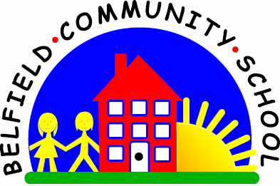
Metropolitan Borough of Rochdale
Education Committee

5.2 Learning to remember and then say the names
of two things
Why is this important?
Verbal understanding can be likened to a ‘list’ of things that need to be
remembered in order to carry out a task. For example, in the two-word level
instruction ‘Give Sam a cup’, the child has to remember ‘Sam’ and ‘cup’.
If children can’t do this, it may be that their auditory memory is not yet
sufficiently developed. Auditory memory can be improved with practice.
-----------------------------------------------------------------------------------------------------------
What to do
• Gather together a selection of pictures of everyday things.
These could be cards or cut out from magazines.
• Place a few cards (e.g. six) face-down on the table.
• Choose two cards but don’t show them to the child.
• Look at your cards and say what they are (e.g. ‘I’ve got a dog and a table’).
• Ask ‘Can you remember what cards I’ve got?’
• If the child is right, show your cards and reinforce:
‘Well done! A dog and a table!’
• If the child finds it difficult or remembers just one item, repeat what cards you have, emphasising the key words (e.g. ‘I’ve got dog and table’).

