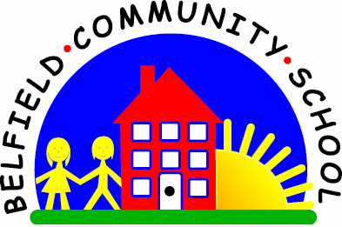
Metropolitan Borough of Rochdale
Education Committee

5.9 Understanding what things are for
Why is this important?
Children begin to be able to categorise things into groups by learning their
functions (e.g. things to eat, wear, drive).
This also helps acquire more vocabulary.
----------------------------------------------------------------------------------------------------------
What to do
• Gather together some familiar toys/objects:
★ Cup, brush, apple, chair, hat, pencil.
• Start by putting out two things and ask the child to find an object by its function:
★ ‘What do we eat?’
★ ‘What can we sit on?’
★ ‘What do we wear?’
N.B. Remember not to look at or point to the object for which you are asking.
• Guide the child to the right choice if you need to. Repeat the instruction and
demonstrate the function (e.g. ‘Sit doll on the chair’, ‘Pretend to eat the apple’).

