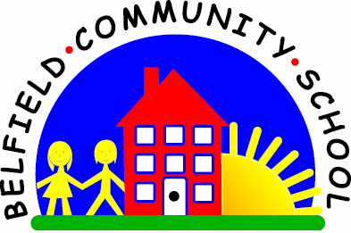
Metropolitan Borough of Rochdale
Education Committee

7.4 Learning the meaning of ‘why’
Why is this important?
‘Why’ questions help to develop causal relations, that is something
happened because of something else (e.g. the boy is crying because he
fell off his bike). As verbal reasoning skills develop, children learn that
‘why’ questions can probe increasingly more abstract concepts.
---------------------------------------------------------------------------------------------------------
What to do
• Collect some simple action pictures that illustrate ‘cause and effect’ activities.
• Use ‘why’ as you ask the child about the pictures, e.g.
★ ‘Why has the man got his umbrella?’
■ ‘Because it’s raining.’
★ ‘Why is the girl running?’
■ ‘Because she’s trying to catch the bus.’
★ ‘Why can’t the boy reach the cake?’
■ ‘Because he’s too small.’
★ Include questions here about feelings/emotions that the child can relate to
his/her own experience (e.g. ‘Why can’t the boy reach the cake? Because he’s
too small. How does he feel?’).
• Encourage sentence completion (e.g. ‘Why has the man got his umbrella?
Because …’).
• If this doesn’t do the trick, model the right response.

