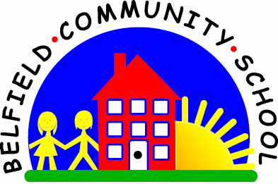
Metropolitan Borough of Rochdale
Education Committee

7.8 Understanding opposites: ‘wet’/‘dry’
Why is this important?
Opposites are used to describe concepts (e.g. an oven is ‘hot’, a fridge is
‘cold’) whilst recognising that other words (e.g. ‘warm’, ‘tepid’, ‘lukewarm’)
represent various positions on the continuum between these two poles.
These linguistic concepts are important in developing cognitive skills too.
----------------------------------------------------------------------------------------------------------
What to do
• Start by introducing one of the pair of concepts (e.g. ‘wet’).
• Take a trip round the house, park or school, talking about things that are
wet (e.g. washing, rain, puddles, tap, hose, drinks, paint).
• Feel and talk about what ‘wet’ is like (e.g. wash your hands, jump in
puddles, make hand-prints with wet paint).
• Think of ‘wet’ things with the child and draw them on a piece of paper. Make
a collage of ‘wet’ things by printing/ cutting out and sticking pictures.
• When the child is familiar with the word and concept ‘wet’, move on to
learn ‘dry’, going through the same activities. Once ‘wet’ and ‘dry’ have
been learnt individually, talk about them together (e.g. put the ‘wet’
washing on the line and it will ‘dry’; wash your hands and then ‘dry’ them).

