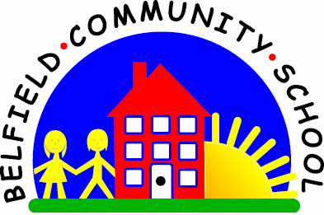
Metropolitan Borough of Rochdale
Education Committee

8.2 Understanding that things that go
together are not always the same

Why is this important?
Children need to learn how words relate to each other but also how they
differ from other words (e.g. an apple and carrot are both foods but apples
are fruits whereas carrots are vegetables). This helps to build semantics
(word meaning) and expands vocabulary.
----------------------------------------------------------------------------------------------------------
What to do
• Gather together some pictures of items in a particular category (e.g. food). Use
magazines, supermarket promotional leaflets, cut the labels off tins, packets and
jars or draw some foods, to get a range of items.
• Using a scrapbook, exercise book or plain paper, think about how the food items
could be divided further, e.g.
★ Fruits vs. vegetables.
★ Hot vs. cold foods.
★ Things eaten for breakfast/lunch/dinner/tea.
★ Hard vs. soft foods.
• Choose two groups (e.g. hot vs. cold foods). Stick all the hot foods on one page
and the cold foods on another. Talk about the foods together.
