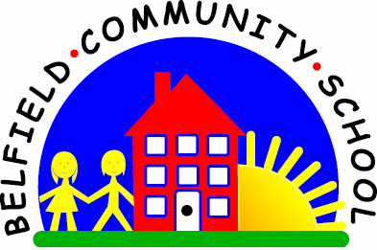



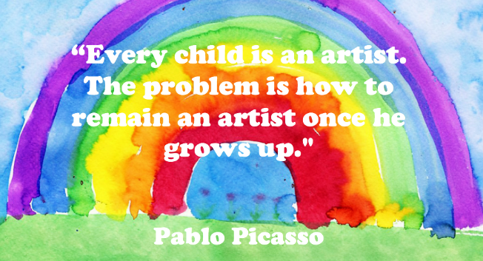

**Art Annual Curriculum Map**

**Belfield Community School**

**Art Annual Curriculum Map**

|  |  |  |  |  |  |  |  |  |
| --- | --- | --- | --- | --- | --- | --- | --- | --- |
| **Art Curriculum Map - Autumn Term** | | | | | | | | |
| **Term** | **Nursery** | **Reception** | **Year 1** | **Year 2** | **Year 3** | **Year 4** | **Year 5** | **Year 6** |
| **Autumn 1** | Explore paint using fingers and brushes  Learning how to paint on an easel  Starting to mark make intentionally  Artist: Jackson Pollock | Colour naming and recognise primary colours  Artist: Van Gogh and Picasso | Drawing  Observational drawing through portraits | Painting  Colour wheel: primary and secondary  Introduction to tints and shades | Drawing and Painting  Shading techniques  Primary, secondary and tertiary colour wheel | Painting  Primary/secondary/tertiary colours application | Drawing and Painting  Shading techniques  Hues and tints applied to recreate a famous piece  Artist: Edvard Munch | Painting  Rose Canal Art  Using skills from previous years |
| **Autumn 2** | Appraising pieces of art  Bonfire Night painting  Artist: Brueghel and Monet | Painting  Colour names for primary, secondary, black and white  Artist: Paul Klee and Mondrian |  |  |  |  | Drawing  Line drawing  Buildings and matchstick people  Artist: LS Lowry |
| **Art Curriculum Map - Spring Term** | | | | | | | | |
| **Spring 1** | Express feelings and ideas through mark making  Explore close shapes with continuous lines  Creating collages and choosing colours  Artist: Vincent Van Gogh |  |  |  | Drawing  Observational drawing of fruits and vegetables  Artist: Carl Warner and Caravaggio | Painting and Drawing  Painting and drawing animals  Artist: Rousseau | Drawing  Landscape and perspective drawings |  |
| **Spring 2** | Exploring lines and dots  Artist: Herve Tullet | Sculpture  Exploring the form of sculpture  Artist: Andy Goldsworthy | Sculpture  Exploring the form of sculpture  Artist: Anthony Gormley |  |  |  |  |
| **Art Curriculum Map - Summer Term** | | | | | | | | |
| **Summer 1** | Show different emotions in their drawing/painting  Explore colours and colour mixing  Creating patterns using different materials  Artist: Chihro Kinjo | Appraising art inspired by nature  Artist: Rousseau and Goldsworthy |  | Drawing:  Explore and recreate Austin’s Butterfly using different mediums | Looking at pattern  Roman Mosaics | Sculpture  Making clay pots | Painting and Sculpture  Creating geometric patterns using print  Creating a piece of a class sculpture  Artists: Eric Broug and Lubna Chowdhury | Craft & Collage  Collaborative works to create a collage of images linked to fair trade  Artist: Tolmeia Gregory |
| **Summer 2** | Drawing and painting fruit  Artist: Paul Cezanne |  |  |  |  |  |  |