



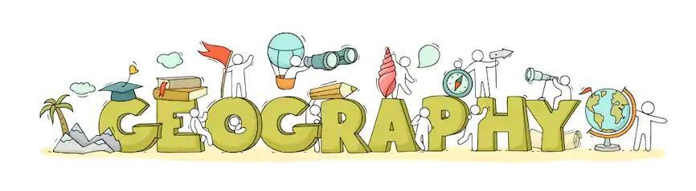

**Geography Annual Curriculum Map**

**Belfield Community School**

**Geography Annual Curriculum Map**

|  |  |  |  |  |  |  |  |  |
| --- | --- | --- | --- | --- | --- | --- | --- | --- |
| **Geography Curriculum Map - Autumn Term** | | | | | | | | |
| **Term** | **Nursery** | **Reception** | **Year 1** | **Year 2** | **Year 3** | **Year 4** | **Year 5** | **Year 6** |
| **Autumn 1** | **Brilliant Beginnings at Belfield**  Exploring our new school and grounds  Exploring outside our area including Belfield Woods  Collecting Leaves, Conkers, Sticks | **Geography of our home**  School and our route to school  Using maps | **Locational Knowledge**  **Where we live**  Locate countries and capital Cities of the UK  Surrounding seas  Characteristics  Using world maps/atlases | **Locational Knowledge**  **Where we live**  Characteristics of capital cities  Using world maps/atlases | **Human and Physical Geography**  **Stone Age/Bronze Age/Iron Age**  Describe and understand key aspects of human geography - settlements | **Locational Knowledge/Place Knowledge**  **Ancient Egypt**  Locate and discuss key human and physical characteristics of locations I am studying | **Locational Knowledge**  **Anglo-Saxons**  Use maps to locate the world’s countries | **Locational Knowledge/Place knowledge**  **Rochdale then and now (Victorians)**  Identifying land-use patterns and how aspects have changed over time  Use key vocabulary to demonstrate understanding of land-use and settlement |
| **Autumn 2** | **Seasons** – looking at autumn and the signs of autumn | **Human and Physical Geography**  **Habitats**  Animals in local areas |  |
| **Geography Curriculum Map - Spring Term** | | | | | | | | |
| **Spring 1** | **Winter Wonderlands/Spring Surprises**  Talking about cold habitats/climates/North and South pole/ Arctic/ Antarctic.  Find China on a map – compare with cold habitat.  Exploring different senses. |  |  | **Place Knowledge/Human and Physical Geography**  **From Belfield to Bangladesh**  Human and physical features  Geographical similarities and differences, UK and non-European country  Weather patterns  Continents/Oceans |  | **Locational Knowledge/Human and physical features**  **The Rainforest**  Use maps to locate the world’s countries  Concentrate on environmental regions  Understand key aspects of human/physical geography  **The Water cycle (Science)**  Understand key aspects of physical geography | **Locational Knowledge/Human and physical geography**  **Mountains, rivers, coasts and natural disasters**  Name and locate key topographical features  Understand key aspects of physical geography including rivers mountains, earthquakes and volcanoes | **Locational Knowledge**  **WW2**  Use maps to locate the world’s countries |
| **Spring 2** | **A Blast from the Past (Transport)**  Understanding the effect of changing seasons on the natural world around them | **Place Knowledge/Human and Physical Geography**  **Local Study - Belfield**  Identify human and physical geography of a small area of the UK  Basic geographical vocabulary |  |
| **Geography Curriculum Map - Summer Term** | | | | | | | | |
| **Summer 1** | **Minibeast Madness/Amazing Animals**  Using a simple map  Naming different countries in the World (home countries/holiday destinations) |  |  |  | **Locational Knowledge/Place knowledge**  **All around the world**  Identify position and significance of latitude, longitude…  Similarities and differences (temperature and rainfall) | **Place Knowledge**  **Ancient Greece**  Geographical similarities and differences of a region in the UK and in European country | **Human and physical geography**  **Ancient Islamic Civilisation**  Understand key aspects of human geography including economic activity and trade links | **Human and physical geography**  **Fair Trade**  Describe and understand key aspects of human geography including trade links and the distribution of natural resources |
| **Summer 2** |  | **Geographical Skills and Fieldwork**  **Field work**  Compass directions  Simple field work and observational skills | **Human and Physical Geography/ Geographical Skills and Fieldwork**  **Seaside then and now**  Basic geographical language  **Fieldwork**  Simple locational and directional language  Fieldwork and observational skills |