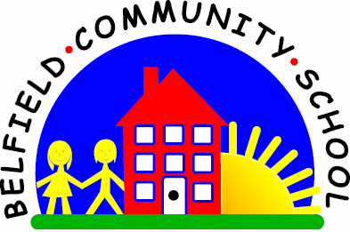Relationships and Health Education at Belfield

Our Vision for RHE  Our RHE curriculum aims to equip all children with the skills & knowledge to enable them to lead a happy, healthy & purposeful life.  We want to develop children who can give back to their local community & the wider world, through being kind, caring and considerate human beings.  We want our pupils to know how to keep themselves safe both online and in real life, and build happy, safe relationships as they negotiate life.  We fully embrace the new statutory curriculum in Relationships and Health Education and have integrated this into our existing PSHE curriculum, ensuring that the statutory objectives are taught in a way that suits the needs of our children and community. We consult with parents where appropriate and want our curriculum to value all the different families within our society. We also recognise the importance of our curriculum being reflective of the local issues and concerns that our community faces. | Content and Sequencing  PSHE Association planning is used to sequence learning. A mapping document has been used to ensure that all the objectives in the new statutory framework for RHE are being taught and have been placed in the appropriate year group to meet the needs of our children.  A planning tool is being developed to ensure that as much support is given to teachers as possible to help structure learning.  Children’s knowledge about a healthy lifestyle, who to speak to about worries (including online) and impact of lifestyle choices on mental and physical health, is revisited over a number of years.  Healthy relationships, dealing with conflict and the effects of bullying are also given high importance and repeated a number of times over a child’s school life, to develop self-respect and respect for others.  Online safety is not just taught explicitly in RHE lessons, but also highlighted in Computing sessions and assemblies.  Parents are supported in keeping their children safe online through parental drop-ins (“How to Keep Your Child Safe”) and are signposted to online materials that give up-to-date advice.  Our RHE curriculum and our Behaviour for Learning Rules, work hand-in-hand to create a respectful school community. The behaviour and manners of adults and children around school is a constant focus and our routines and scripts support this.
Links across the curriculum  English – stories and texts used to support key messages eg Ruby’s Worry; The Most Magnificent Thing etc  Computing – e-safety  Science – healthy lifestyles (see science curriculum  Assemblies – learning powers taught each half-term, assemblies focus on PSHE key theme. Often, stories are used to reinforce key messages  Drama – high importance is given to the impact of drama in giving children the opportunity to reflect on important subjects such as CSE, dangers of drugs and alcohol, anti-bullying and online safety. | Progress/assessment  -Units of work are carefully sequenced so prior knowledge and concepts are built upon, leading to a greater understanding of RHE  -We use our ongoing assessment to inform judgments using PSHE Assoc programmes of study  -At the end of the year, teachers use this information to make a judgment of Working Towards, At Expected or Greater Depth | Support  Children who are identified as vulnerable receive support through Willow Room provision e.g.: Play Therapy; Lego therapy groups; Positive Behaviour Management; Individual support plans (developed through TAPS)  Lessons are taught by teachers, with all children given the opportunity to access Year Group expectations (this may be adjusted for complex SEN e.g. puberty)  SDQs are used to identify specific issues with children who may be struggling with aspects of self-esteem, respect for themselves and others and self-awareness. Intervention is then planned to suit needs, alongside our Learning Mentor/Play Therapist

