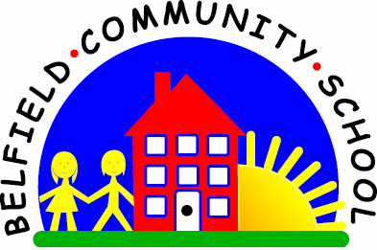



**Religion Annual Curriculum Map**

**Belfield Community School**

**Annual Curriculum Map**

|  |  |  |  |  |  |  |  |  |
| --- | --- | --- | --- | --- | --- | --- | --- | --- |
| **Curriculum Map - Autumn Term** | | | | | | | | |
| **Term** | **Nursery** | **Reception** | **Year 1** | **Year 2** | **Year 3** | **Year 4** | **Year 5** | **Year 6** |
| **Autumn 1** |  | Which Stories are special and why? | Who is a Christian and what do they believe? | Who is Muslim and what do they believe? | What do different people believe about God? | What do different people believe about God? | If God is everywhere, why go to a place of worship? | Is it better to express your religion in arts and architect or charity and generosity? |
| **Autumn 2** |  | Which people are special and why? | How and why do we celebrate special and sacred times?(Christmas) | How and why do we celebrate special and sacred times? (Christmas) | Why is the Bible so important for Christians today? | Why is Jesus inspiring to some people? |
| **Curriculum Map - Spring Term** | | | | | | | | |
| **Spring 1** |  | Which places are special and why? | What makes some places sacred? | Who is Jewish and what do they believe? | Why do people pray? | Why do some people think that life is a journey and what significant experiences mark this? | Why do some people believe God exists? | What would Jesus do?  Can we live by the by the values of Jesus in the 21st Century |
| **Spring 2** |  | Which times are special and why? | How and why do we celebrate special and sacred times? (Easter) | How and why do we celebrate special and sacred times? (Easter and Passover) | Why are festivals important to religious communities?  (Christian/Muslim) | Why are festivals important to religious communities?  (Jewish) |
| **Curriculum Map - Summer Term** | | | | | | | | |
| **Summer 1** |  | Where do we belong? | What does it mean to belong to a faith community?  (Include Eid) | What can we learn from sacred books?  (Include Eid) | What does it mean to be a Christian today? | What does it mean to be a Hindu in Britain today? | What does it mean to be a Muslim in Britain today?  History of Islamic religion | What difference does it make to believe in Ahisma (harmlessness), Grace (the generosity of God) or Ummah (community)? |
| **Summer 2** |  | What is special about our world? | How should we care for others and the world and why does it matter? | How should we care for others and the world and why does it matter? | What can we learn from religions about deciding what is right and wrong? | What can we learn from religions about deciding what is right and wrong? |