





NEWSLETTER DECEMBER 2018


Dear Parents/Carers
Thank you for all your support this term. It’s been very busy as always. Here is a quick reminder of the additional activities we have been part of:
Robinwood, Touchstones, Crucial Crew, School Council day, dance festival and various sporting activities.
We also supported a wonderful collection for the local food bank, Show Racism the Red Card and Children in Need.
The children have been working really hard in class; we hope you enjoy the text messages. We have been using our learning powers to help us be the best we can be.

Remember knowing times tables is the secret to great maths, ask about the times table rockstars and don’t forget, reading every day is the secret to success in life. Please help and encourage your children to do these activities every day. There is help on our school website to support.
The Governors and staff would like to take this opportunity to say have a very Merry Christmas and a lovely holiday and we hope the New Year is a good one for you.
See you on the 7th January.
Mrs Farrell
Head Teacher

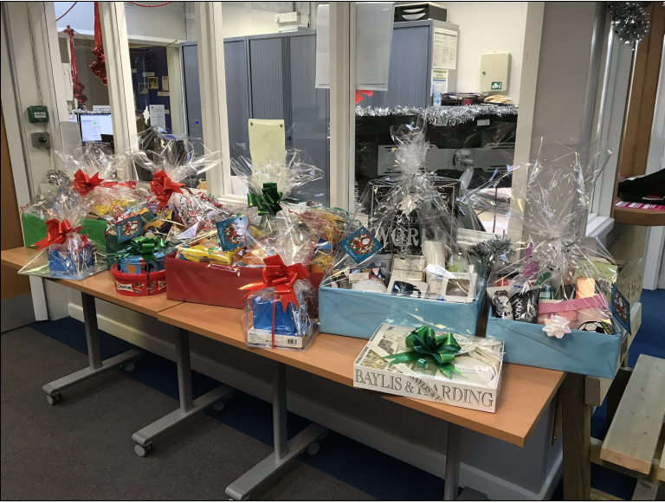
Thank you to everyone who bought tickets for the hamper raffle raising over £150, All the winners have now been notified. Thank you for your support.
The Christmas showing of the film “The Littlest Reindeer” for KS1 and also KS2 was a huge success, the children enjoyed the crisps and drinks and we raised approx. £140.00. This will go towards resources for school for the children. We will be organising another film event in the New Year, so please keep an eye on future events.

Have you got any free time? Would you like to be involved with “The Friends of Belfield”?
Our FOB is about much more than simply fundraising. The FOB exists to provide closer links between home and school and it is an excellent way to bring staff, parents and friends together socially in support of the school, working towards a common goal. It is fun too – just ask any of the Committee members or FOB helpers. Obviously, as in any organisation, we have experienced some challenges but with the continued support of parents and staff, our FOB has always succeeded in its efforts.
Achieving More Together
Friends of Belfield
If you would like to get involved, either speak to your child’s class teacher or
call in at the school office for more details. We need new members.
Please do get in touch.

Mr Shahid
Chair
Friends of Belfield

FORTH COMING EVENTS
Monday 18th December – Pantomime “Puss in Boots”
Tuesday 19th December – Christmas Dinner
Thursday 20th December – Christmas Parties (£2.00 donation)
Friday 21st December – School finishes for the holidays from 1.00pm
Monday 7th January – School re-opens at 8.45am

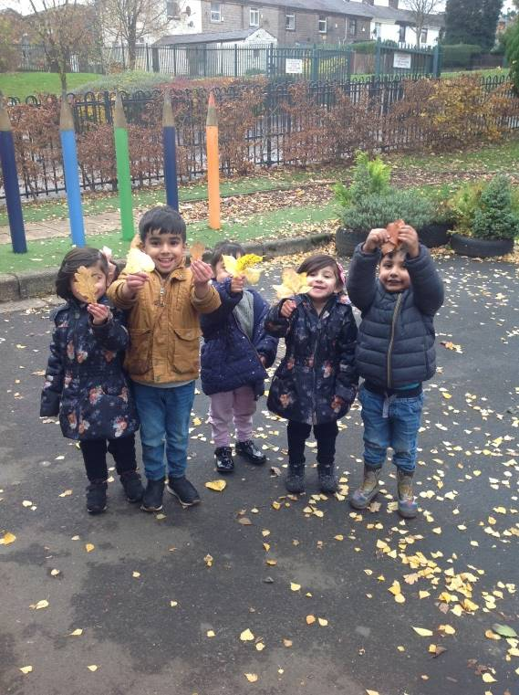
NURSERY
The Nursery children have loved learning all about Autumn. We caught leaves in the windy weather and talked about the changing seasons. We are impressed that so many of our children are able to put their own coats on.

We have enjoyed reading books about bears and woodland animals. Everyone has used their voice to join in with words from our stories. We have all been busy mark making and are beginning to write letters from our names.
The children are all becoming more confident at counting and recognising numerals to 10, please keep counting with your child at home.

Thank you for your support at our festive sing-a-long.
Have a happy and safe holiday.

Nursery Staff

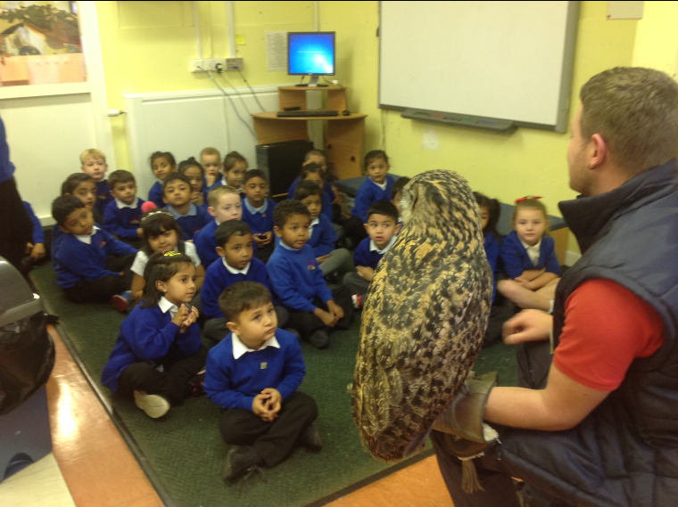
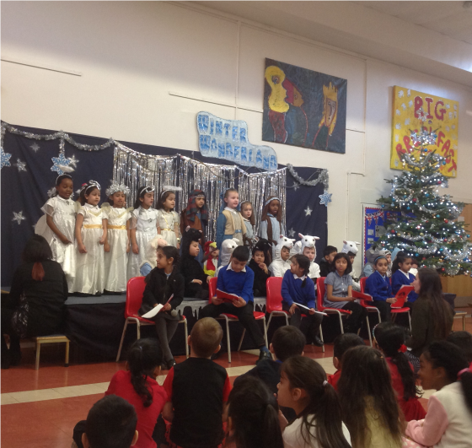
CLASS 1 & 2
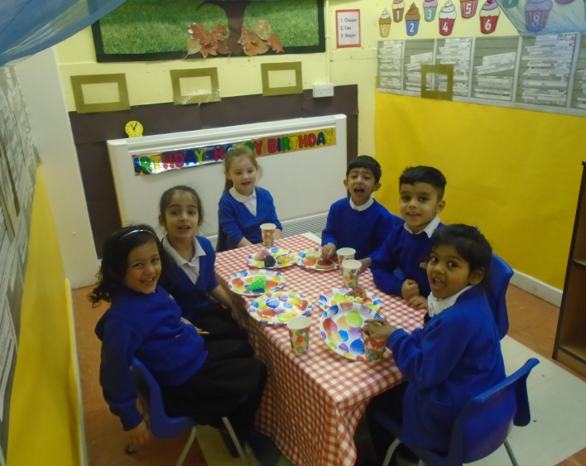
The children in Reception have been very busy during their first term. We have loved learning about dinosaurs, autumn, transport and celebrations, and we even got to meet an owl! We have made great progress with our phonics, and are using it more to read and write. We are getting to be more independent when getting changed for P.E. and we are developing our listening skills during our carpet sessions. We all really enjoyed learning the songs and performing in our nativity. Well done to all of the children for a super first term at school!

CLASS 3, 4 & 5
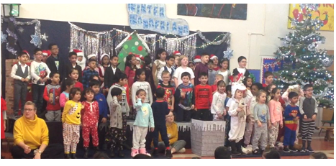
Year 1 and 2 have been busy and having lots of fun learning about castles, knights and dragons. We have enjoyed reading many books which include; George and the Dragon, How to Catch a Dragon, The Dragon Machine and Rapunzel. Whilst reading these books we have been learning lots of new words. We hope you enjoyed our Winter Wonderland sing-a-long, all the children worked so hard to learn their songs and dances. Thanks to all who attended and sent in costumes, the children were thrilled to see you.
Our next topic is called Secrets of the Sea. We will be learning about things that live in the sea and what goes on down in the deep too.
We wish you all a Merry Christmas and look forward to seeing you in the New Year.

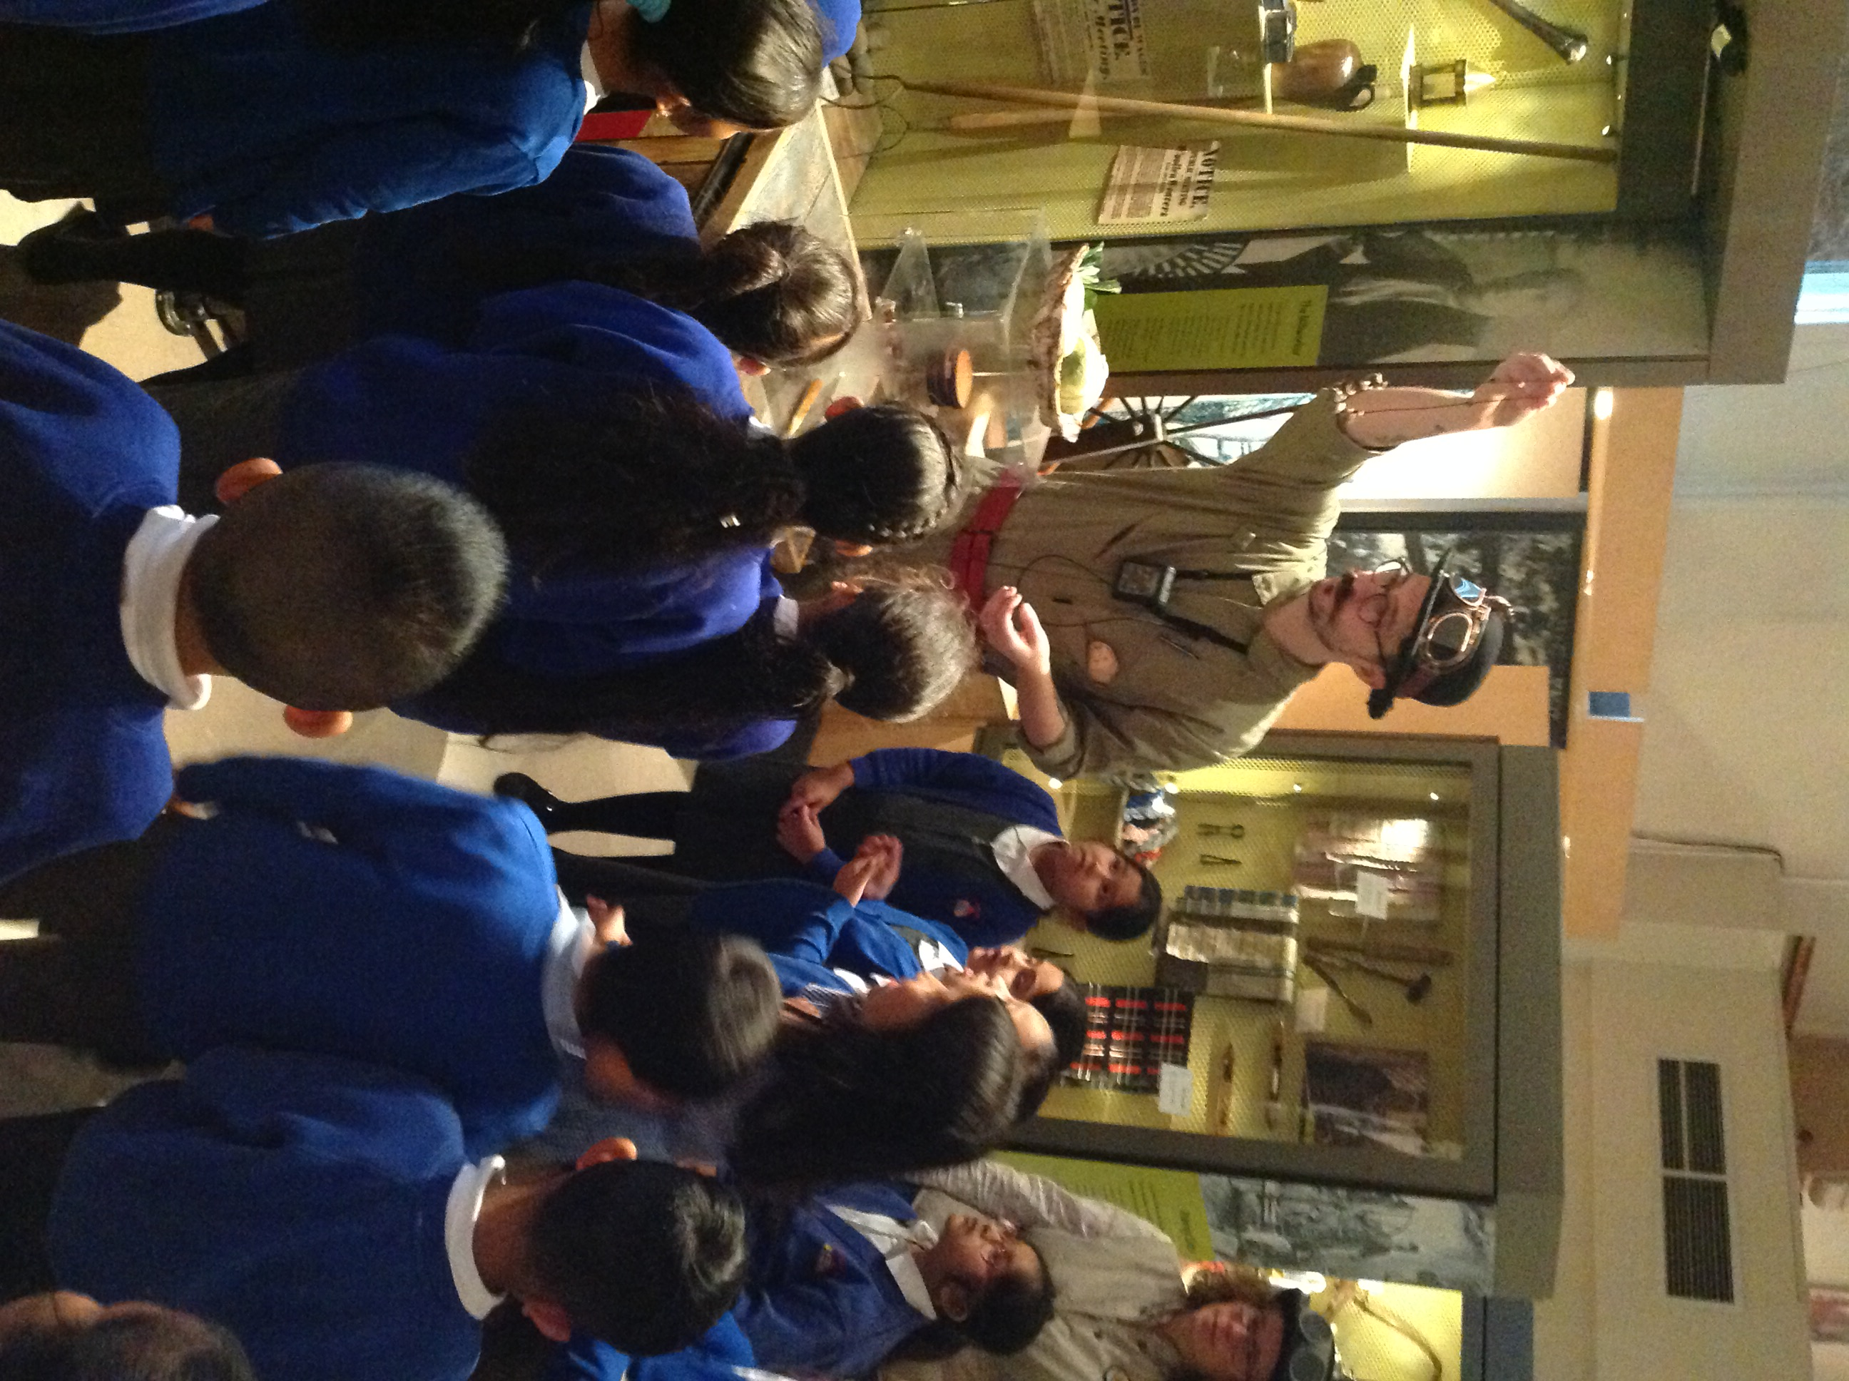
CLASS 6, 7 & 8

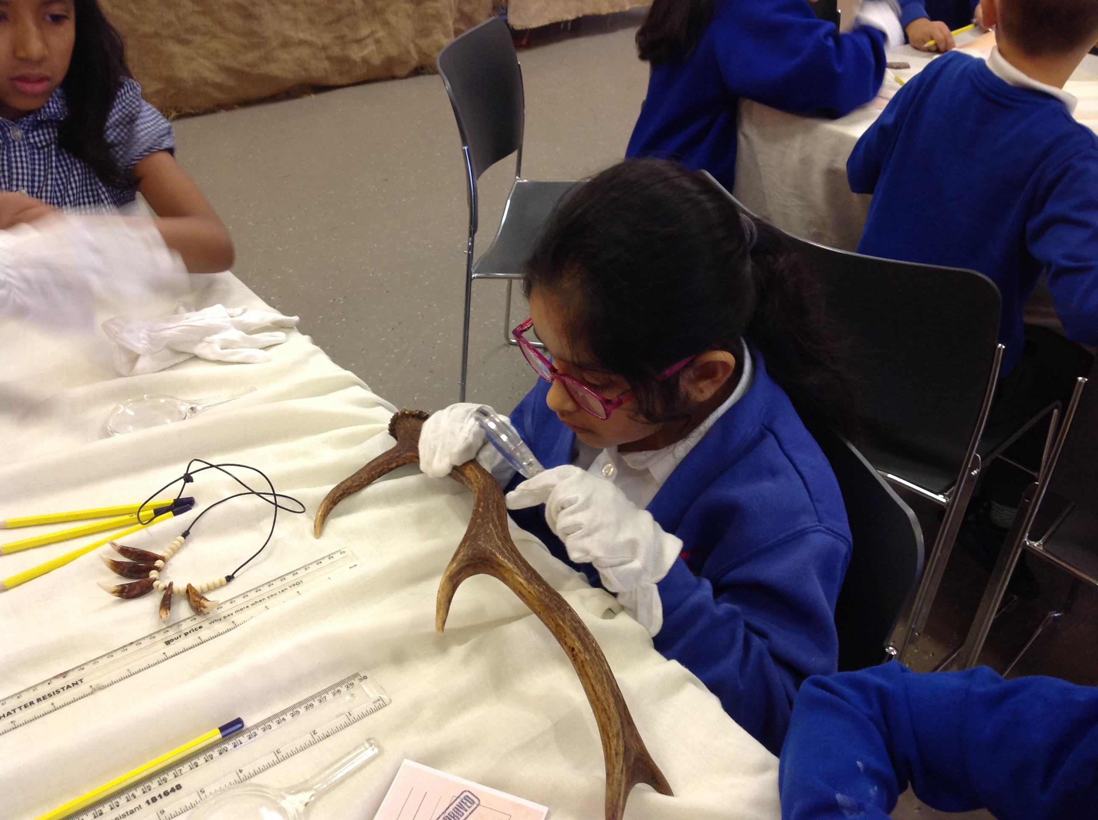
This tem Year 3 & 4 have enjoyed learning about the Stone Age to Roman era in History. Earlier in the term, we visited Touchstones Museum where we saw artefacts, made pots and even designed our own museum exhibition!

We have enjoyed a healthy start to this term, 6 children from classes 6 & 7 did a super job representing Belfield in the IPLCN dance festival last month, check out the video on out school website!

Our football team also did us proud, participating in the IPLCN football tournament, playing superbly and behaving brilliantly ☺

We have also been enjoying the Daily Mile three mornings a week to give us a great start to the day. Class 8 have stepped up to battle against Class 9 in TT Rockstars, they have all been working incredibly hard to learn their times tables, the teachers are very proud of their hard work.

We would like to thank you for all your support with this as well as with your donations to our reverse hamper. Have a lovely holiday and see you all in the New Year.

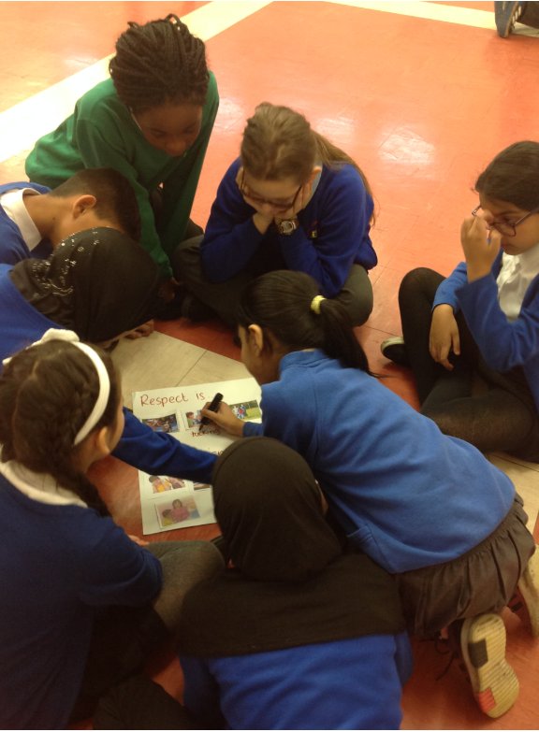
CLASS 9, 10 & 11
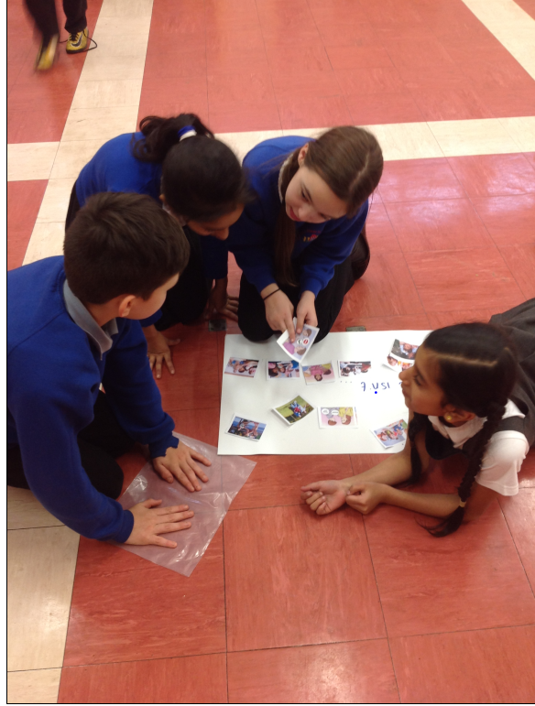
Year 5 and 6 have had an exciting term learning about the Anglo Saxons and the Vikings. We have really enjoyed reading Beowulf and Viking Boy and have produced some excellent work.
We now have three Rock Heros in Year 5 and 6. Well done Fahmida, Mu’Azzin and Zain A. Keep playing TT rockstars ans see if you too can become a Rock Hero.

Class 10 have had weekly Circle Time sessions with Miss Wilson, Miss Tetlow and Mrs Lord to help us learn PHSE. Most recently we have been learning about respect and what it means to respect others, ourselves, and the thigs around us.

This term we had a very busy fundraising week. We raised nearly £400 and now have a fantastic new library full of wonderful books.

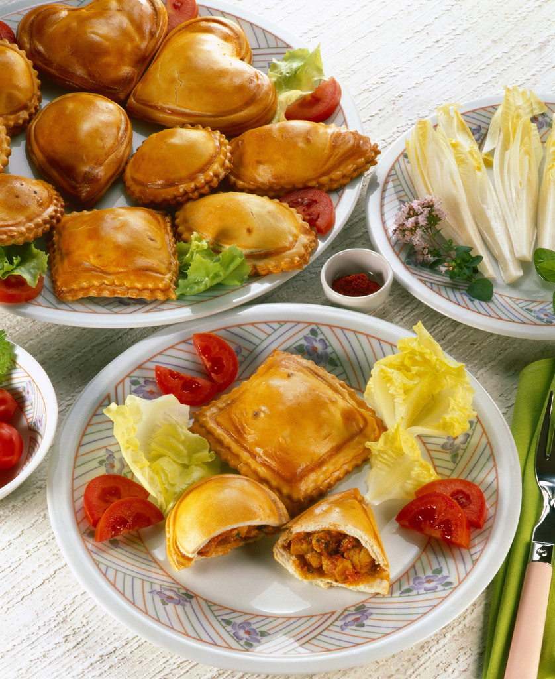
FREE SCHOOL MEALS
As you may be aware all children in reception, year 1 and year 2 who currently pay for school dinners or bring a packed lunch from home are entitled to a Universal Infant Free School Meal (UIFSM), irrespective of income and family circumstances.
However, if you or your partner are receiving benefits you will need to complete a free school meal form for all year groups (form available from the school office). This way the school is allocated “Pupil Premium” funding. The money is used in school to support pupils to ensure they reach their full potential. Please speak to the school office if you think you may be eligible or have any queries.
Thank you.


DANCE FESTIVAL
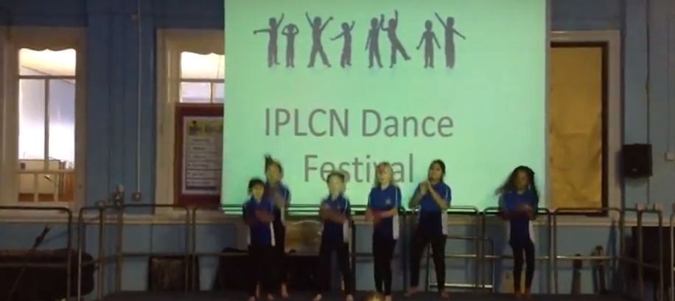
Children from Key Stage Two took part in the IPLCN Dance Festival at Marland Hill Primary School in November. They performed to Meghan Trainor’s Better When I’m Dancin’. All the children were amazing and we have some super dancers in school. Well done to everyone who took part.


SCHOOL DINNERS
All dinner money must be paid on a Monday morning and if we receive no dinner money after two weeks your child will require a packed lunch or be sent home for dinner. Just a reminder that the cost of a school dinner is £2.10 per day / £10.50 per week. Don’t forget envelopes are given out at the beginning of each term. Please use these and ensure you write your child’s name and class. Please always enclose the correct money as change will no longer be given out. If you would like your child to change from school dinners /packed lunches, please inform the office, as the change can only be made at the start of each term and not part way through. Thank you.

RECEPTION PLACES SEPTEMBER 2019
Just a reminder that the closing date for next September’s Reception places is Tuesday 15th January 2019. Apply at www.rochdale.gov.uk/schooladmissions or call into No1 Riverside for more information.

POLITE REMINDERS
- Will parents please remember that No Parking is allowed under any circumstances on the road outside the school gates. Hopefully you will have noticed the no parking signs. Cars should not come into school grounds when dropping off or picking up children.
- Dogs are not allowed on the school premises.
- Book Bags – please ensure your child brings their bag to school every day.
- Water Bottles – We encourage all our children to bring fresh water bottles every day (sorry no juice).
- Please ensure all uniform is clearly marked with your child’s name


PARKING
Please be aware that parking outside school is putting the lives of our children at risk.
Please DO NOT park on the yellow zig zag lines or opposite. The school grounds are for the use of staff only and should NOT be used for parents dropping off and collecting their children from school. Please be aware that staff do need to leave the school premises for meetings, training etc and blocking in/double parking can cause untold complications. The safety of our children is of the upmost importance so please put the children first and park away from school. Thankyou.


BAD WEATHER
As the bad weather draws in please be careful when walking to school, as the paths can be very icy and slippery. When on school grounds, please walk on the footpaths that have been gritted for your safety.
Thank you.

School will close for the Christmas Break on Friday 21st December. Children can be collected from 1.00pm

School will re-open on Monday 7th January 2019 at 8.45am.
If you have any queries or concerns, please do speak to your child’s teacher or the school office.
HAPPY HOLIDAYS TO YOU ALL

