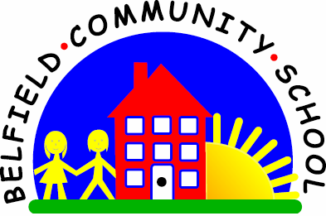

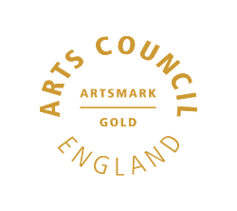
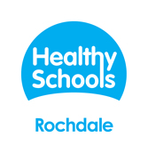


NEWSLETTER DECEMBER 2019


Dear Parents/Carers
Thank you for all your support this term. It’s been very busy as always. Children working really hard and having plenty of fun.

I would just like to take the time on your behalf to say thank you to Miss Kelsey. She will be leaving us at Christmas to take up a new post at Rochdale Additional Needs Team. She has worked at Belfield for 20 years and has always worked tirelessly to support the children and parents of Belfield. We wish her well and we know she will keep in touch. She will be really missed, many many thanks from us all.
Remember knowing times tables is the secret to great maths, ask about the times table rockstars and don’t forget, reading every day is the secret to success in life. Please help and encourage your children to do these activities every day. There is help on our school website to support.
The Governors and staff would like to take this opportunity to say have a very Merry Christmas and a lovely holiday and we hope the New Year is a good one for you.
See you on the 6th January.
Mrs Farrell
Head Teacher

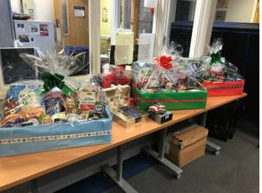
Thank you to everyone who bought tickets for the hamper raffle raising over £70, All the winners have now been notified. Thank you for your support.
The Christmas showing of the film “The Magic Sack of Santa Claus” for KS1 was a huge success, the children enjoyed the crisps and drinks and we raised approximately £120. This will go towards resources for school for the children. We will be organising another film event in the New Year, so please keep an eye on future events.

Have you got any free time? Would you like to be involved with “The Friends of Belfield”?
Our FOB is about much more than simply fundraising. The FOB exists to provide closer links between home and school and it is an excellent way to bring staff, parents and friends together socially in support of the school, working towards a common goal. It is fun too – just ask any of the Committee members or FOB helpers. Obviously, as in any organisation, we have experienced some challenges but with the continued support of parents and staff, our FOB has always succeeded in its efforts.
Achieving More Together
Friends of Belfield
If you would like to get involved, either speak to your child’s class teacher or
call in at the school office for more details. We need new members.
Please do get in touch.

Mrs Kemp
Chair
Friends of Belfield

EVENTS
Monday 9th December – Pantomime “Snow White”
Tuesday 17th December – Christmas Dinner & Christmas Jumper Day
Wednesday 18th December – Christmas Parties (£2.00 donation)
Thursday 19th December – School finishes for the holidays from 1.30pm
Monday 6th January 2020– School re-opens at 8.45am

NURSERY
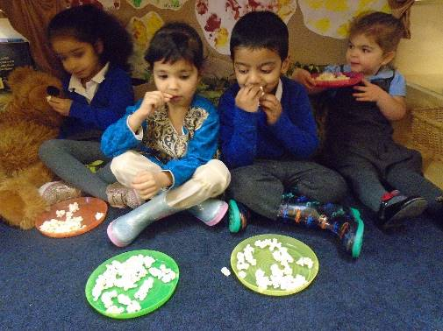
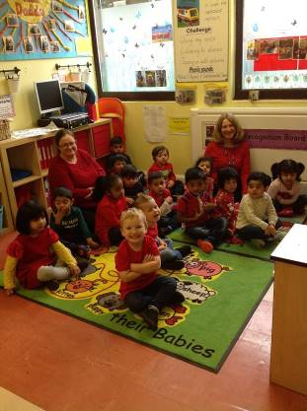
Nursery have had such a busy term. The children are now all settled and ready to learn. We have had lots of fun finding out about Autumn and reading books about bears. We have been tasting a variety of food, discovering colours, exploring outside and making friends. We have used our voices to say the words in stories and to join in with songs and nursery rhymes. The children have also been naming shapes, counting to 10 and are beginning to use positional language.

Have a safe and happy holiday.

All our very best wishes for the coming year.
Nursery Staff

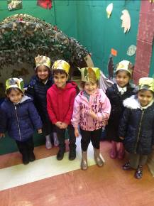
CLASS 1 & 2
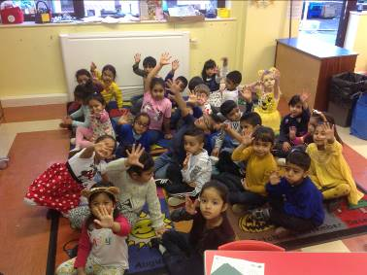
Reception have really settled into being in school this half term. Our topic has been Walk in the Woods, and we have had visits from owls, seen a Gruffalo during forest school and we all went on a bear hunt at story cafe. There are lots of photographs of what we have been up to on our blog on the website. Thanks to all parents for reading with and supporting the children at home following our phonics workshop and reading cafe, the
children are doing really well!
Have a lovely break and see you all in 2020.

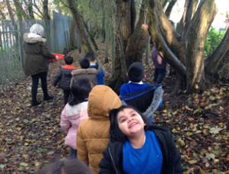
CLASS 3 & 4
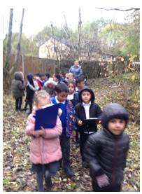
This term in Year 1 we have been learning all about animals. We have read lots of stories about animals such as, Mr. Wolf’s pancakes where we even wrote our own instructions on how to make a pancake. We have been learning about the animals in our local area, we became detectives and went on a hunt for evidence of these animals. We then made bird feeders to help look after the wildlife during winter. In maths we have been learning how to add and subtract, we are fantastic mathematicians! We have had great fun this term and have been working really hard.
Have a lovely holiday and see you all in the New Year.

CLASS 5 & 6
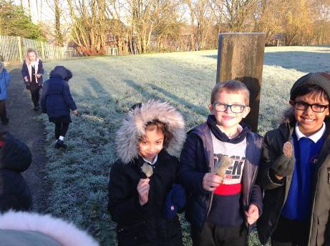
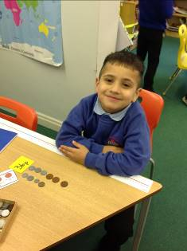
In Year Two we have enjoyed learning about Henry VIII and castles. We learnt how to use money in numeracy and draw arrays. We also watched ‘Snow White’ when the pantomime came into school and we have been practicing really hard for our own Christmas performance for our families.
We wish you all a Merry Christmas and look forward to seeing you in the New Year.

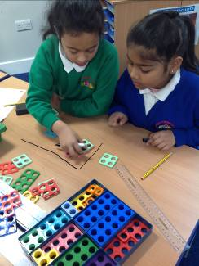
CLASS 7 & 8
Year 3 have been working very hard this term. In maths, we have been learning different methods of multiplication and division and have enjoyed reading Charlie and the Chocolate factory during English lessons. For the past few weeks, children have been awarded Golden Tickets when demonstrating excellent behaviour and attitudes towards learning. The tickets will allow them entry to a special showing of the film at the end of term. We are all very proud of the children's successes and look forward to continuing these efforts after the holidays.

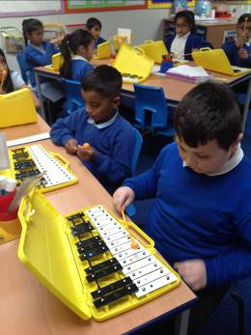
CLASS 9 & 10
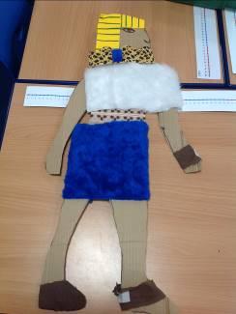
This term we have been learning about Ancient Egypt. The children have enjoyed exploring Ancient Egyptian life by looking at pictures of ancient homes in Egypt and comparing it to modern houses in the UK. We have also looked at fashion and the children had the opportunity to design their own clothes for Ancient Egyptian men and women. In Science, the children have been learning about the digestive system. In Literacy, the children have been reading Charlie and the Chocolate Factory and wrote their own newspaper reports about the lucky winners! In Maths, we have been learning about the different methods for multiplication and division in Music we have been playing the Glockenspiels. Well done to all the Year 4s for a fantastic term! We are all very proud of the effort and hard work the children have put in their work, well done!

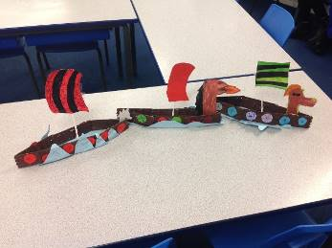
CLASS 11,12,13 & 14
Year 5 and 6 have had a busy start to the year. Year 5 having been looking at Anglo Saxons and Vikings as their topic and have created their very own Viking longboats. Year 6 have been looking at the Rise of Rochdale and the Industrial Revolution during the Victorian Era and were able to visit Touchstones to learn about the start of the co-operative movement in Rochdale. In English we have based our work on the book 'Wild Boy'. The children have thoroughly enjoyed reading this and have produced some brilliant writing including narratives, setting descriptions, diaries and a newspaper report. In Science we have covered the topics of Forces, Animals including Humans and Light. Year 5 have been visited by Mrs Hollinworth from Hollingworth Academy, who has taught science lessons to the children at school and all of Year 5 and 6 have also been lucky enough to visit Hollingworth Academy to complete a science investigation using bunsen burners in a science laboratory! The children thoroughly enjoyed the experience and now can't wait to study science at high school! Year 6 also had a fantastic time completing a variety of outdoor activities at Robin Wood - we were all have a go heros! A number of children have also represented the school in competitions including dance, netball and archery. Year 5 and 6 should be very proud of the work they have completed this term!
We would like to wish everyone a very Happy Christmas and look forward to seeing you all in the New Year.

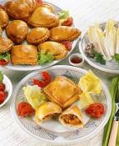
FREE SCHOOL MEALS
As you may be aware all children in reception, year 1 and year 2 who currently pay for school dinners or bring a packed lunch from home are entitled to a Universal Infant Free School Meal (UIFSM), irrespective of income and family circumstances.
However, if you or your partner are receiving benefits you will need to complete a free school meal form for all year groups (form available from the school office). This way the school is allocated “Pupil Premium” funding. The money is used in school to support pupils to ensure they reach their full potential. Please speak to the school office if you think you may be eligible or have any queries.
Thank you.


ON LINE PAYMENTS
Well done if you have signed already.In the new year we want to move to a cashless school where all payments for dinner money, school bags, school trips and school shows will have to be made online. If you haven’t already created an account or require an online access letter for the website please contact the school office who will be happy to help.
Thank you for your continued support.


SCHOOL DINNERS
All dinner money must be paid on a Monday morning and if we receive no dinner money after two weeks your child will require a packed lunch or be sent home for dinner. Just a reminder that the cost of a school dinner is £2.20 per day / £11.00 per week. Don’t forget envelopes are given out at the beginning of each term. Please use these and ensure you write your child’s name and class. Please always enclose the correct money as change will no longer be given out. Payments can also be made online using your child’s account. If you would like your child to change from school dinners /packed lunches, please inform the office, as the change can only be made at the start of each term and not part way through. Thank you.

RECEPTION PLACES SEPTEMBER 2020
Just a reminder that the closing date for next September’s Reception places is Wednesday 15th January 2020. Apply at www.rochdale.gov.uk/schooladmissions or call into No1 Riverside for more information.

POLITE REMINDERS
- Will parents please remember that No Parking is allowed under any circumstances on the road outside the school gates. Hopefully you will have noticed the no parking signs. Cars should not come into school grounds when dropping off or picking up children.
- Dogs are not allowed on the school premises.
- Book Bags – please ensure your child brings their bag to school every day.
- Water Bottles – We encourage all our children to bring fresh water bottles every day (sorry no juice).
- Please ensure all uniform is clearly marked with your child’s name


PARKING
Please be aware that parking outside school is putting the lives of our children at risk.
Please DO NOT park on the yellow zig zag lines or opposite. The school grounds are for the use of staff only and should NOT be used for parents dropping off and collecting their children from school. Please be aware that staff do need to leave the school premises for meetings, training etc and blocking in/double parking can cause untold complications. The safety of our children is of the upmost importance so please put the children first and park away from school. Thankyou.


BAD WEATHER
As the bad weather draws in please be careful when walking to school, as the paths can be very icy and slippery. When on school grounds, please walk on the footpaths that have been gritted for your safety.
Thank you.

School will close for the Christmas Break on Thursday 19th December. Children can be collected from 1.30pm

School will re-open on Monday 6th January 2020 at 8.45am.
If you have any queries or concerns, please do speak to your child’s teacher or the school office.
HAPPY HOLIDAYS TO YOU ALL

